

# Batch: *A-4* Roll No.: *16010422211* Experiment No.: 01

**Aim:** Formulation of a problem definition for specific real world DMS system and Drawing ER/EER diagram for the same.



**Resources needed:** MS-office



# Theory:

**Entity relationship model** is a data model which represent the overall logical structure of database and it is very useful in mapping the meanings and interactions of real world enterprises onto a conceptual schema.

The E-R model employs three basic notations:

**Entity sets:** An entity set is a set of entities of the same type that share the same properties .(an entity is a real world object)

**Relationship sets:** Relationship set is a set of relationships of the same type.(relationship is an association among several entities)

**Attributes:** Attributes are properties of entity set used to describe it. Different types of attributes are composite, multivalued, derived and simple.

In **extended E R model** we have three additional concepts:

**Specialization:** The process of designating the subgroupings within an entity set is called specialization( finding specialized attributes)

e.g. in entity set person we have two types of entities like customer and employee. Both are person but employee have specialized attribute salary and customer have rating.

**Generalization:** It is a top down design process in which multiple entity sets are synthesized into a higher level entity set on the basis of common features.

e.g. customer entity set and employee entity set both have common attributes like name, address, age which can be used as attributes of higher level entity set person. **Aggregation:** it is an abstraction through which relationships are treated as higher level entities.

The most important use of the E-R diagram is it represents some constraints like total and partial participation, one to one, many to many, many to one, one to many mapping etc.

# Symbols used in EER diagram:

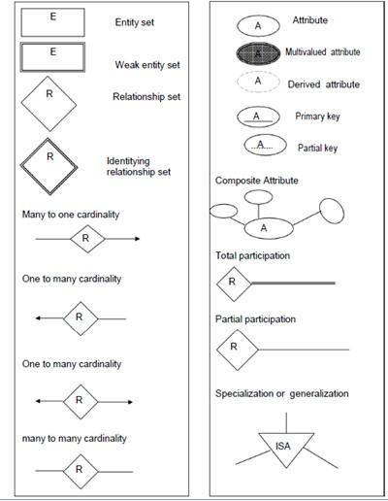



**Procedure:**

Identify the real world objects to start drawing the diagram

1. Entity – An real world object which can be converted into table name.
2. Entity type – It defines the collection of similar type of entities.
3. Attributes – Properties of entity which describes the entity. Attributes are of different types
   1. Atomic Attributes
   2. Composite Attributes
   3. Single valued attributes
   4. Multivalued Attributes
   5. Derived Attributes
4. Relationship – When one entity refers to another entity type a relationship exists between the two entities.
5. Relationship types – A relationship type R among n entity types defines a set of associations among entities of other types.
6. Weak entity – the entity depends on another entity is called as weak entity.
7. Specialization – this is process of defining a set of subclasses of an entity type .It is derived from a super class depending upon different attributes.
8. Generalization – It is the process of abstraction in which we suppress the differences among several entity types grouping some entities and eliminating common features. We generalize them into a single super class.
   1. Disjoint – In this, entity can be a member of any one of the subclass
   2. Overlap – In this, entity can be a member of more than one subclass.
   3. Total – All the entities are member of any one of the subclasses.
   4. Partial – Entity is not a member of any one the subclass.
9. Union – the subclass represent collection of objects.

This detailed problem statement gives the clarification about the database design.

This is tool to find out missing functional dependencies to convert the schema to the appropriate normal form.

Formulate the problem definition to get the detailed description of the problme domain so that entities can be easily identified from the problem definition.

There are many components used into EER.

1. First find out the real world objects as entities.
2. Find out the attributes which will describe the object.
3. Find the relationships and the participation constraints.
4. Apply object oriented fundamentals and get the specialization and generalization objects.
5. Draw the diagram.



**Results: (Document printout/handwritten)**

1. Problem definition
2. ER/EER diagram

**Example:**

Problem Definition for COMPANY database system

The company is organized into DEPARTMENTs. Each department has a name, number and an employee who *manages* the department. We keep track of the start date of the departmentmanager.

Each department *controls* a number of PROJECTs*.* Each project has a name, number and islocated at a single location.

It stores each EMPLOYEE’s social security number, address, salary, gender, and birthdate. Each employee *works for* one department but may *work on* several projects. It keep track of the number of hours per week that an employee currently works on each project. We also keep track of the *direct supervisor* of each employee.

Each employee may *have* a number of DEPENDENTs. For each dependent, we keep track of their name, gender, birthdate, and relationship to employee.

____________________________________________________________________________

1. PROBLEM STATEMENT FOR ***AGRICULTURAL MANAGEMENT SYSTEM*:**

*The Agricultural Management System faces the challenge of efficiently organizing and managing vast amounts of data related to crops, farmers, weather conditions, land parcels, markets, and agricultural resources.*

*The Agricultural Management system has entities like CROP, FARMER, WEATHER etc.*

*Crop has crop ID(primary key), crop name, Expected yield as the attributes.*

*Crop is affected by Weather (another entity), is grown by Farmer (entity), is sold in Market (entity) and is associated with Gov Policies (yet another entity). It has weak entity Quality.*

*Weather has attributes like weather ID, Temperature, Rainfall etc*

*Farmer has attributes like Farmer Id, Farmer Name, Address, Aadhar no. etc*

*Market has attributes like Crop Price, Crop quantity, Market name, Market ID*

*Gov Policies has attributes like Poliy ID, Policy Name etc*

*Quality has attributes like Crop ID, Check ID, Date etc*

*Crop has a 1:N relationship with Weather and Farmer.*

*Crop has a N:N relationship with Gov policies*

*Crop has a N:1 relationshipwith Market.*

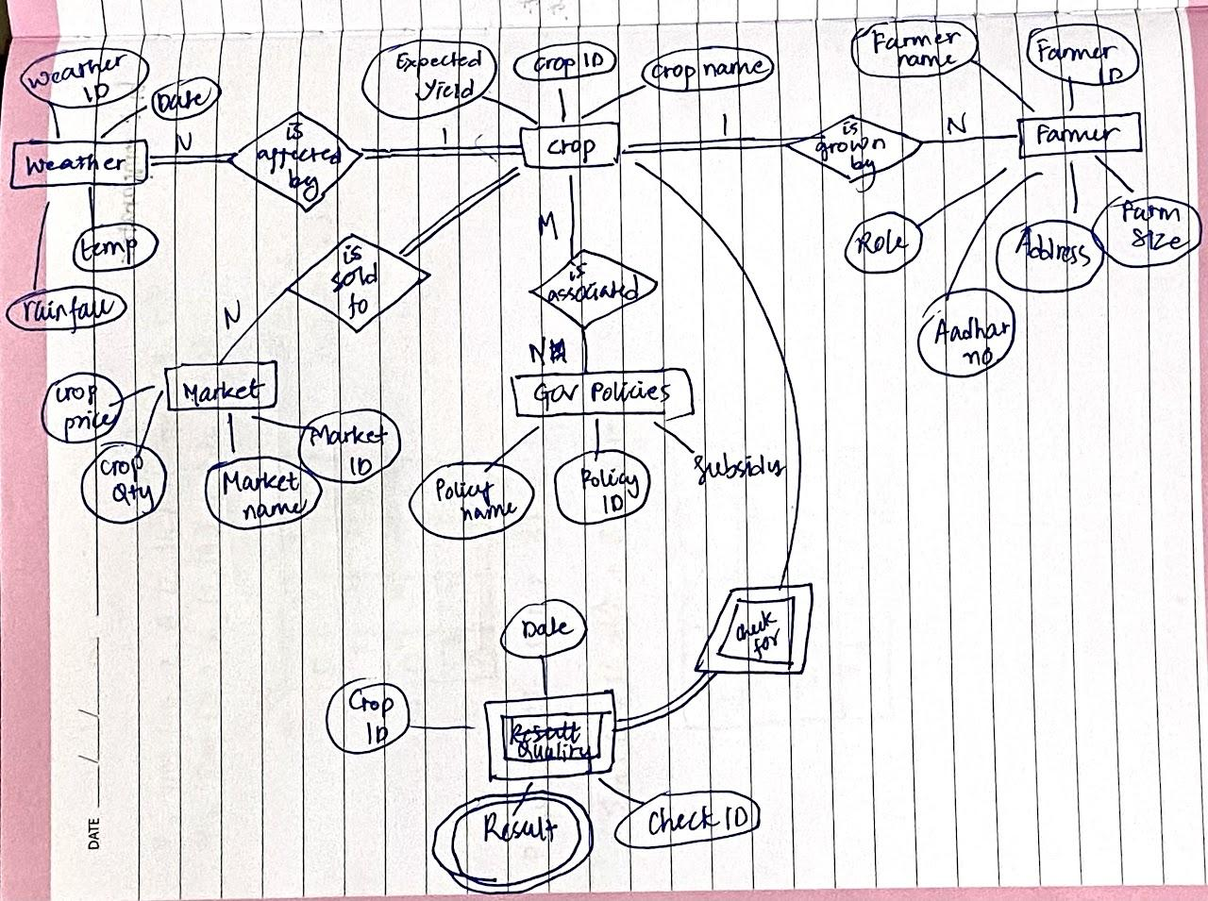



# 

# Outcomes:

# CO2. Formulation of a problem definition and Drawing ER /EER diagram. (Virtual Lab).



**Questions:**

**Q1 Explain total and partial participation with example Q2 differentiate between primary key and unique key**

1. **Total Participation:** *Total participation means that every entity in an entity set must participate in a relationship. In other words, every entity must be connected to a relationship. Represented by a double line in an ERD. EX: Consider two entities: Department and Employee. In an employee management system, every employee must belong to a department; there cannot be an employee who is not part of any department. An employee cannot exist in the system without being associated with a department.*

**Partial Participation***: Partial participation means that not every entity in an entity set is required to participate in a relationship. Represented by a single line in an ERD. EX: Consider two entities: Library and Book. In a library database, not every book needs to be currently checked out; some books might be on the shelves and not borrowed. A book can exist in the system without being currently checked out to any library member.*

|  | *Primary Key* | *Unique Key* |
| --- | --- | --- |
| *Uniqueness* | *Must contain unique and non-null values.* | *Must contain unique values; NULL values are allowed.* |
| *NULL Values* | *Does not allow NULL values.* | *Allows NULL values, but treats them as unique.* |
| *Number of Columns* | *Can consist of one or multiple columns.* | *Can consist of one or multiple columns.* |
| *Table Uniqueness* | *Ensures uniqueness in a table.* | *Ensures uniqueness in a table.* |
| *Clustered Index* | *Often automatically creates a clustered index on the primary key column(s).* | *Does not automatically create a clustered index.* |
| *Table Relationships* | *Frequently used in defining relationships between tables.* | *Can also be used in relationships, but with less significance than primary keys.* |
| *Use in JOINs* | *Frequently used in JOIN operations.* | *Can be used in JOIN operations, but does not have the same impact as primary keys.* |



**Conclusion:**

*Learnt how to make an Entity relationship Diagram with entities and attributes.*

**Reference books:**

1. Elmasri and Navathe, “Fundamentals of Database Systems”, 6th Edition, Pearson Education
2. Korth, Slberchatz,Sudarshan, :”Database System Concepts”, 6th Edition, McGraw

3. <http://vlabs.iitkgp.ernet.in/se/4/>